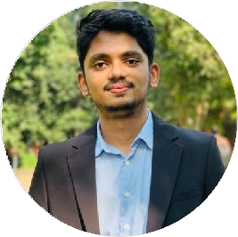Affnan Sawad

### Full Stack Developer & SQA Tester

I am a passionate MERN Stack Developer and SQA tester with hands-on experience building responsive web applications. Skilled in JavaScript, React.js, Node.js, and automated testing, I am committed to writing clean, efficient code and ensuring high-quality user experiences. Always eager to learn new technologies and grow as a full-stack developer, I strive to solve complex problems and contribute to impactful projects.

# EDUCATION

## BSC in CSE

### International Islamic University Chittagong

*06/2023 - Present Courses*

 Computer Science and

Engineering

## Higher Secondary Certificate

### Hazi Mohammad Mohsin College

*12/2019 - 12/2021*

## Secondary School Certificate

### Govt. Muslim High School

*01/2013 - 02/2019*

# WORK EXPERIENCE

## Front Desk Officer

### Sandwip Overseas

*01/2022 - 01/2025*

# SKILLS

MERN STACK , Manual & Automation Testing

**PERSONAL PROJECTS**

Fusion Car Ltd. ( https://car-fusion-ltd.web.app/ )

Royal-Enfield-Bangladesh ( https://royal-enfield- a59da.web.app/ )

Bistro Restaurent( https://bistro-boss-restaurent- 2e929.web.app/ )

eShop ( https://e-shop-bd-25.netlify.app/ )

# ORGANIZATIONS

Sandwip Overseas (01/2021 - 02/2025)

# LANGUAGES

English

*Full Professional Proficiency*

Hindi

*Full Professional Proficiency*

Urdu

*Full Professional Proficiency*

Bangla

*Full Professional Proficiency*



[affnansawad2002@gmail.com](mailto:affnansawad2002@gmail.com)

01540796323

[github.com/AffnanSawad](https://github.com/AffnanSawad)

**INTERESTS**

Software Development , AI , Machine Learning